**Azure DevOps Services**

In this quickstart, you learn how to sign up for a free organization with a Microsoft account. You also learn how to invite your teammates.

Sign up for Azure DevOps to upload and share code in free, unlimited private Git repositories.

Then, connect to your favorite development tool like Eclipse, Xcode, Visual Studio, IntelliJ, or Android Studio to work on apps anytime, anywhere.

**Sign up for Azure DevOps with a personal Microsoft account**

1. Select the sign-up link for [Azure DevOps](https://go.microsoft.com/fwlink/?LinkId=307137).
2. Enter your email address, phone number, or Skype ID for your Microsoft account. If you're a Visual Studio subscriber and you get Azure DevOps as a benefit, use the Microsoft account associated with your subscription. Select **Next**.
3. Enter your password and select **Sign in**.

If you don't have a Microsoft account, you can [create a Microsoft account](https://login.live.com/login.srf?lw=1) at this time.

1. To get started with Azure DevOps, select **Continue**.
2. Enter a name for your organization. The name can't contain spaces or special characters (such as / \ [ ] : | < > + = ; ? or *), can't end in a period or comma, must be less than 256 characters, and must be unique within the DevOps namespace. You can also choose between several locations for where you want your data hosted. Select **Continue**.

You see the following dialog box as your organization is created.

Congratulations, you're now an organization owner!

To sign in to your organization at any time, go to https://dev.azure.com/{yourorganization}.

1. Enter a name for your project and select the visibility. The name can't contain spaces or special characters (such as / : \ ~ & % ; @ ' " ? < > | # $ * } { , + = [ ]), can't begin with an underscore, can't begin or end with a period, and must be 64 characters or less. Visibility can be either public or private. With public visibility, anyone on the internet can view your project. With private visibility, only people who you give access to can view your project. Select **Create project**.

**Welcome to your project**

When your project has been created, the welcome page appears.

**Note**

Your first project was created by using a Git repository and the [**Agile process**](https://docs.microsoft.com/en-us/azure/devops/boards/work-items/guidance/agile-process). If you want a project that uses the Team Foundation Version Control (TFVC) repository or the Scrum or CMMI process, see [**Choose a process**](https://docs.microsoft.com/en-us/azure/devops/boards/work-items/guidance/choose-process) for a comparison of processes. Then, you can choose a process by [**adding another project**](https://docs.microsoft.com/en-us/azure/devops/organizations/projects/create-project).

Select one of the following tasks to get started:

* **Boards** to begin [adding work items](https://docs.microsoft.com/en-us/azure/devops/boards/work-items/view-add-work-items).
* **Repos** to open the [Repos > Files](https://docs.microsoft.com/en-us/azure/devops/repos/git/clone) page. There, you can clone or import a repository or [initialize a README file](https://docs.microsoft.com/en-us/azure/devops/project/wiki/project-vision-status) for your project summary page.
* **Pipelines** to start [defining a pipeline](https://docs.microsoft.com/en-us/azure/devops/pipelines/index).
* **Test Plans** to start [defining test plans and test suites](https://docs.microsoft.com/en-us/azure/devops/test/create-a-test-plan).
* [Manage your services](https://docs.microsoft.com/en-us/azure/devops/settings/set-services) to disable the visibility of one or more services.

To get started managing your project, see [Get started as an administrator](https://docs.microsoft.com/en-us/azure/devops/user-guide/project-admin-tutorial).

For more information about organizations and projects, see these articles:

* [Define organizations and projects](https://docs.microsoft.com/en-us/azure/devops/user-guide/define-organizations-and-projects)
* [About projects and scaling your organization](https://docs.microsoft.com/en-us/azure/devops/organizations/about-projects)
* [Manage projects](https://docs.microsoft.com/en-us/azure/devops/organizations/projects/index)

**Invite team members**

Give a team member access to your organization by adding their email address to your organization.

1. Sign in to your organization (https://dev.azure.com/{yourorganization}).
2. Select Organization settings **Organization settings**.
3. Select **Users** > **Add new users**.
4. Complete the form by entering or selecting the following information:
   * **Users:** Enter the email addresses (Microsoft account) for the users. You can add several email addresses by separating them with a semicolon (;). An email address appears in red when it's accepted.
   * **Access level:** Leave the access level as **Basic** for users who will contribute to the code base. To learn more, see [About access levels](https://docs.microsoft.com/en-us/azure/devops/organizations/security/access-levels).
   * **Add to project:** Select the project you named in the preceding procedure.
   * **DevOps Groups:** Leave as **Project Contributors**, the default security group for users who will contribute to your project. To learn more, see [Default permissions and access assignments](https://docs.microsoft.com/en-us/azure/devops/organizations/security/permissions-access).

**Note**

You must add email addresses for [**personal Microsoft accounts**](https://account.microsoft.com/account) unless you plan to use [**Azure Active Directory (Azure AD)**](https://azure.microsoft.com/documentation/articles/active-directory-whatis/) to authenticate users and control organization access. If a user doesn't have a Microsoft account, ask the user to [**sign up**](https://signup.live.com/) for a Microsoft account.

1. When you're done, select **Add** to complete your invitation.

### Git

You can use Git repositories to host and collaborate on your source code. For an overview of code features and functions, see [Git](https://docs.microsoft.com/en-us/azure/devops/repos/git/overview?view=azure-devops).

Set permissions across all Git repositories by making changes to the top-level **Git repositories** entry. Individual repositories inherit permissions from the top-level **Git Repositories** entry. Branches inherit a subset of permissions from assignments made at the repository level. For branch permissions and policies, see [Set branch permissions](https://docs.microsoft.com/en-us/azure/devops/repos/git/branch-permissions) and [Improve code quality with branch policies](https://docs.microsoft.com/en-us/azure/devops/repos/git/branch-policies).

|  |  |  |  |  |
| --- | --- | --- | --- | --- |
| **Task** | **Readers** | **Contributors** | **Build Admins** | **Project Admins** |
| Clone, fetch, contribute to pull requests, and explore the contents of a repository | checkmark | checkmark | checkmark | checkmark |
| Contribute to a repository, create branches, create tags, manage notes |  | checkmark | checkmark | checkmark |
| Create, delete, and rename repositories |  |  |  | checkmark |
| Edit policies, Manage permissions, Remove others' locks |  |  |  | checkmark |
| Bypass policies when completing pull requests, Bypass policies when pushing, Force push (rewrite history, delete branches and tags) (not set for any security group) |  |  |  |  |

The Project Collection Build Service can read from all repositories by default. Any pipeline which runs with project collection scope can potentially read any repository in the organization/collection. You can remove this permission for a repository: set "Read" to "Deny" for the Project Collection Build Service.

### TFVC

|  |  |  |  |  |
| --- | --- | --- | --- | --- |
| **Task** | **Readers** | **Contributors** | **Build Admins** | **Project Admins** |
| Contribute to a centralized version control, including Code Review (Check in, label, lock, merge, pend a change) | Read only | checkmark | checkmark | checkmark |
| Check in, revise, undo, or unlock other users' changes |  |  |  | checkmark |
| Manage branches, manage permissions |  |  |  | checkmark |

## Set Git repository permissions

You can set the permissions for all Git repositories for a project, or for a single repository.

**Note**

Your web portal uses either the **New navigation** or **Previous navigation** user interface. Choose the **New navigation** tab if the **New Navigation** feature is enabled. You'll see a vertical sidebar along with other navigational features when **New Navigation** has been enabled for the signed-in user or the organization. Choose **Previous navigation** when you see a top-level, blue-bar—indicating that **New navigation** isn't enabled. For more information, see [**Web portal navigation**](https://docs.microsoft.com/en-us/azure/devops/project/navigation/index).

* [New navigation](https://docs.microsoft.com/en-us/azure/devops/organizations/security/set-git-tfvc-repository-permissions?view=azure-devops&tabs=new-nav#tabpanel_9auX2-D8gy_new-nav)
* [Previous navigation](https://docs.microsoft.com/en-us/azure/devops/organizations/security/set-git-tfvc-repository-permissions?view=azure-devops&tabs=new-nav#tabpanel_9auX2-D8gy_previous-nav)

1. Open the web portal and choose the project where you want to add users or groups. To choose another project, see [Switch project, repository, team](https://docs.microsoft.com/en-us/azure/devops/project/navigation/go-to-project-repo?view=azure-devops).
2. To set the set the permissions for all Git repositories for a project, choose **Git Repositories** and then choose the security group whose permissions you want to manage.

For example, here we choose (1) **Project Settings**, (2) **Repositories**, (3) **Git repositories**, (4) the **Contributors** group, and then (5) the permission for **Create repository**.

To see the full image, click to expand.

[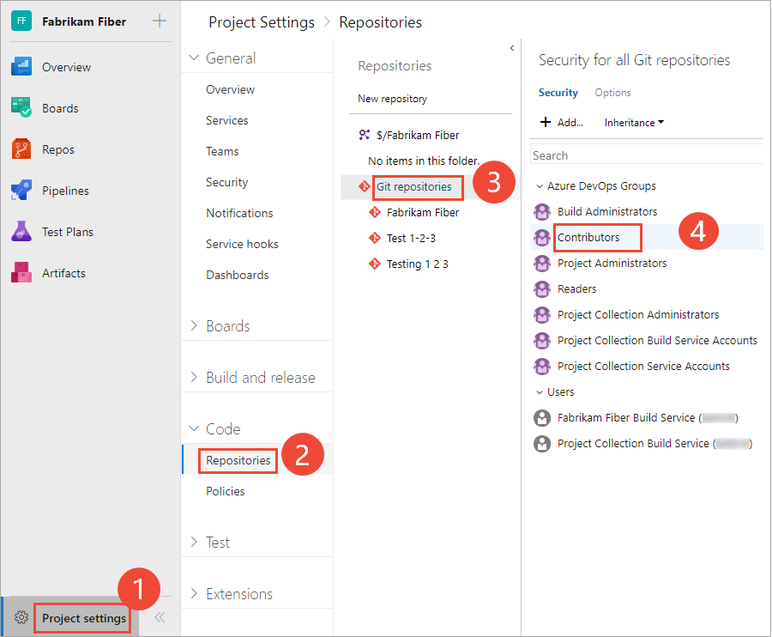](https://docs.microsoft.com/en-us/azure/devops/organizations/security/_img/git-tfvc-perm/open-repository-security-vert.png?view=azure-devops#lightbox)

Otherwise, choose a specific repository and choose the security group whose permissions you want to manage.

1. When done, choose **Save changes**.

## Set TFVC repository permissions

* [New navigation](https://docs.microsoft.com/en-us/azure/devops/organizations/security/set-git-tfvc-repository-permissions?view=azure-devops&tabs=new-nav#tabpanel_9auX2-D8gy-1_new-nav)
* [Previous navigation](https://docs.microsoft.com/en-us/azure/devops/organizations/security/set-git-tfvc-repository-permissions?view=azure-devops&tabs=new-nav#tabpanel_9auX2-D8gy-1_previous-nav)

1. To set the set the permissions for the TFVC repository for a project, choose **TFVC Repository** and then choose the security group whose permissions you want to manage.

For example, here we choose (1) **Project Settings**, (2) **Repositories**, (3) the **TFVC repository**, (4) the **Contributors** group, and then (5) the permission for **Manage branch**.

To see the full image, click to expand.

1. Save your changes.

## Create a new repo

Manage any folder with source code or Visual Studio solution in Git by creating a repo for them. Later you can connect this Git repo to a remote Git repo to share your work with others.

* [Visual Studio](https://docs.microsoft.com/en-us/azure/devops/repos/git/creatingrepo?view=azure-devops&tabs=visual-studio#tabpanel_Kelr-g3ZmQ_visual-studio)
* [Command Line](https://docs.microsoft.com/en-us/azure/devops/repos/git/creatingrepo?view=azure-devops&tabs=visual-studio#tabpanel_Kelr-g3ZmQ_command-line)

### Create a repo

* [Create a repo from a new solution](https://docs.microsoft.com/en-us/azure/devops/repos/git/creatingrepo?view=azure-devops&tabs=visual-studio#from-a-new-solution)
* [Create a repo from an existing solution](https://docs.microsoft.com/en-us/azure/devops/repos/git/creatingrepo?view=azure-devops&tabs=visual-studio#from-an-existing-solution)
* [Create a repo in an empty folder](https://docs.microsoft.com/en-us/azure/devops/repos/git/creatingrepo?view=azure-devops&tabs=visual-studio#in-an-empty-folder)
* [Connect a local repo to a remote](https://docs.microsoft.com/en-us/azure/devops/repos/git/creatingrepo?view=azure-devops&tabs=visual-studio#connect-a-local-repo-to-a-remote)

### From a new solution

Create a new Git repo for your new Visual Studio solution by selecting **Create new Git repository** when creating the solution:

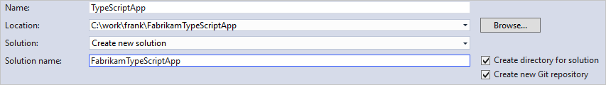

### From an existing solution

To create a repo from an existing solution not in version control, select the **Publish**button in the bottom-right of the lower status bar Visual Studio publish button. This creates a new Git repo in the same directory as your solution and opens up the **Publish** view in Team Explorer so you can [push](https://docs.microsoft.com/en-us/azure/devops/repos/git/pushing?view=azure-devops) your code to Azure Repos or another remote Git repository.



### In an empty folder

1. Open the **Connect** view in Team Explorer by choosing **Projects** then **Manage Connections** from the context menu.
2. Under **Local Git Repositories**, select **New** and enter a folder where the repo will be created. This directory must be empty.
3. Select **Create** to create the repo.

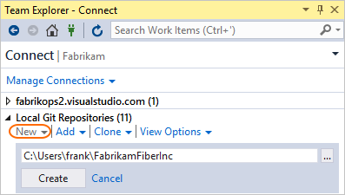

### Connect a local repo to a remote

To connect a local repository to a hosted remote Git repository to share your work, go the **Settings** page in Team Explorer. Select **Repository Settings**. Under **Remotes**, select **Add**.

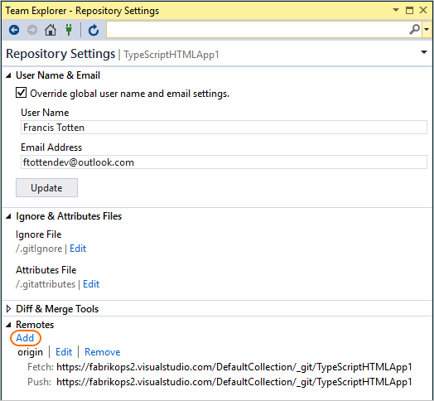

Enter origin in the **Name** field and enter the [clone URL](https://docs.microsoft.com/en-us/azure/devops/repos/git/clone?view=azure-devops#clone_url) for your repo in the **Fetch**field. Make sure that **Push matches fetch** is checked and select **Save**.

<https://docs.microsoft.com/en-us/azure/devops/organizations/billing/set-up-billing-for-your-organization-vs?view=azure-devops>

For Billing just go through above url don’ do any settings.

1. Choose the https://docs.microsoft.com/en-us/azure/devops/_img/icons/project-icon.pngAzure DevOps logo to open **Projects**, and then choose **Organization settings**.

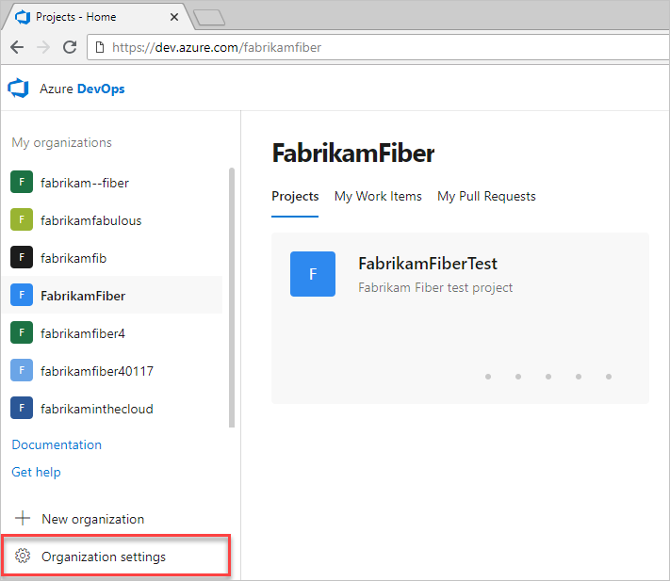

1. Select a service from the sidebar. Settings are organized based on the service they support. Expand or collapse the major sections such as **Work** and **CI/CD** to choose a page.

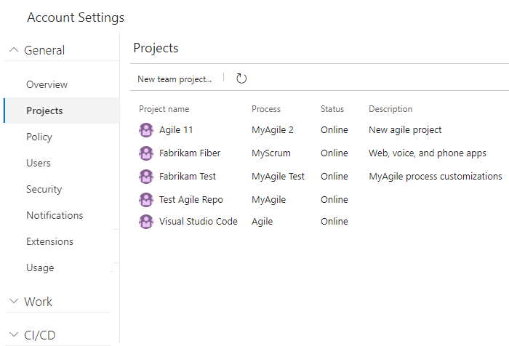

**New navigation** isn't supported on TFS at this time. Choose **Previous navigation** guidance.

1. Choose the https://docs.microsoft.com/en-us/azure/devops/_img/icons/gear-icon.pnggear icon to open **Organization Settings**.

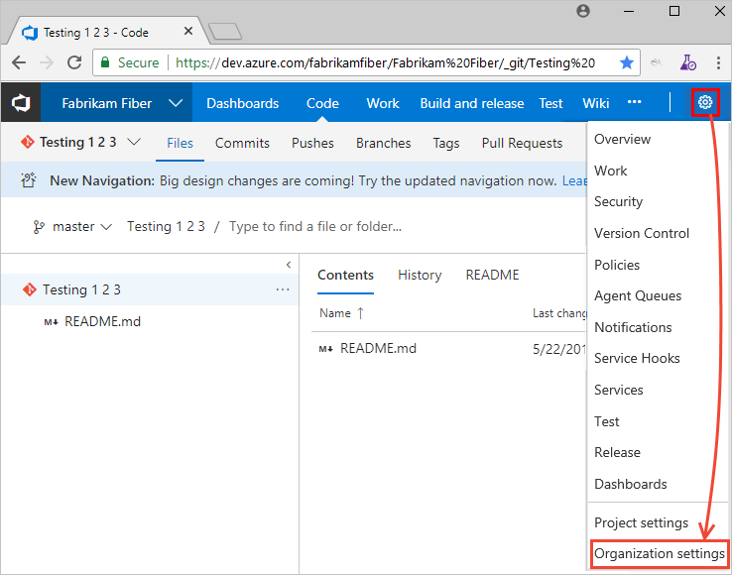

1. From there, you can choose a page. Settings are organized based on the service they support.

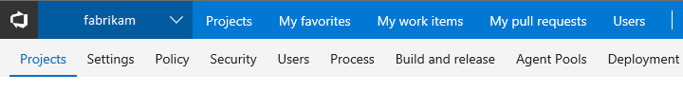

## Delete project

Caution

If you want to access project data while the project is deleted (without [restoring it](https://docs.microsoft.com/en-us/azure/devops/organizations/projects/restore-project?view=azure-devops)) you should [save project data](https://docs.microsoft.com/en-us/azure/devops/organizations/projects/save-project-data?view=azure-devops).

1. Open the https://docs.microsoft.com/en-us/azure/devops/_img/icons/actions-icon.png?view=azure-devopsactions icon menu for the project that you want to delete and choose **Delete**.

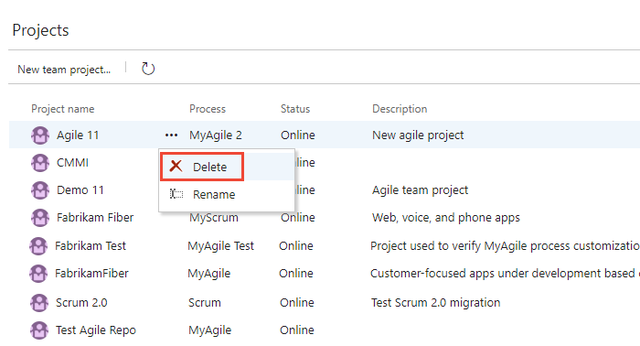

If you don't see the actions icon actions icon image, either you're not accessing Azure DevOps or you're not a member of the Project Collection Administrators group. Learn about [joining the Project Collection Administrators group](https://docs.microsoft.com/en-us/azure/devops/organizations/security/set-project-collection-level-permissions?view=azure-devops).

1. Enter the name of the project, and then select **Delete**.

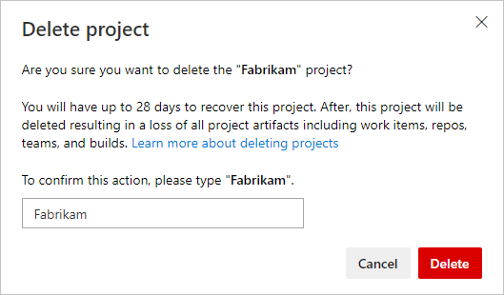

Creating branches

<https://docs.microsoft.com/en-us/azure/devops/repos/git/branches?view=azure-devops&tabs=visual-studio>

Gothrough the video

<https://docs.microsoft.com/en-us/azure/devops/repos/git/pushing?view=azure-devops&tabs=visual-studio>

Share code with Push watch the video

<https://docs.microsoft.com/en-us/azure/devops/repos/git/pulling?view=azure-devops&tabs=visual-studio>

Update code with fetch and pull watch the video

To Delete the project

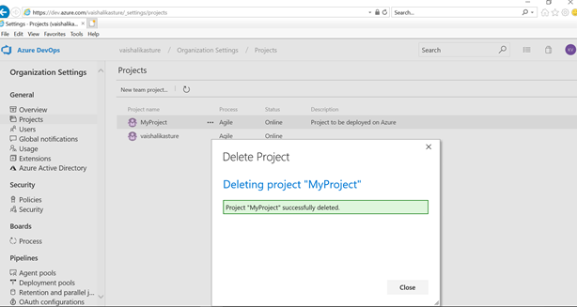

Usage

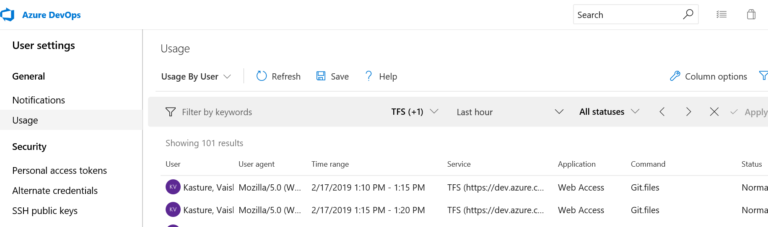

**Connect to a project or repository**

Team Explorer connects Visual Studio to projects in Azure DevOps. You can manage source code, work items, and builds. The operations available to you depend on which source control option—Git or Team Foundation version control (TFVC) —was selected to manage source code when the project was created.

Tip

If you open Visual Studio and the Team Explorer pane doesn't appear, choose the **View>Team Explorer** menu option from the tool bar.

From the **Connect** page, you can select the projects you want to connect to and quickly switch connection to a different project and or repository. For details, see [Connect to a project](https://docs.microsoft.com/en-us/azure/devops/organizations/projects/connect-to-projects?view=azure-devops).

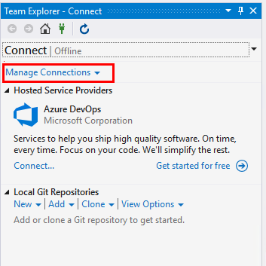

The Git and TFVC repos support different pages and functions